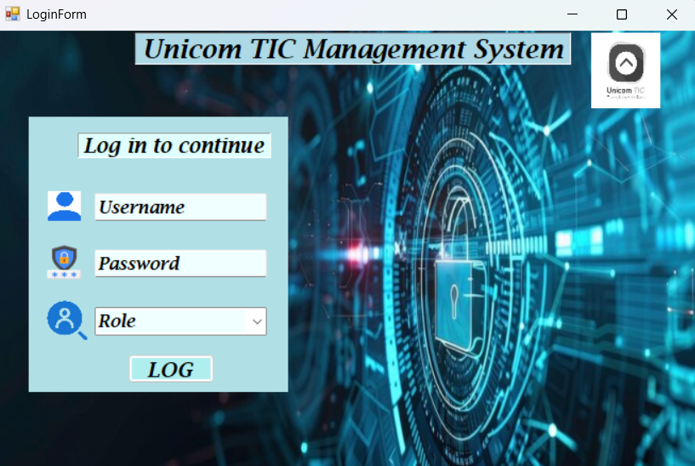**User Login Form and connection between Login Form and Users Table**

LoginForm

* Initially, the Admin can log in using the **role 'Admin'** with the **username 'admin'** and **password '123'**.
* When you click on the Username, Password, or Role text box, the placeholder text will disappear, allowing you to type or select the appropriate value.
* After entering the **Username**, **Password**, and selecting the **Role**, the system checks the data against the **Users** table in the database.

If all three fields match a record correctly:

* A **"Login successful"** message will be displayed.
* You will be redirected to the **Main Dashboard** based on your role.

On the Dashboard:

* A **welcome message** will be shown with your **logged-in username**.
* If the user is an **Admin**, all buttons and features will be visible and accessible.
* If the user is **Staff**, **Lecturer**, or **Student**, access will be limited based on their role, and unauthorized buttons will be **hidden**.

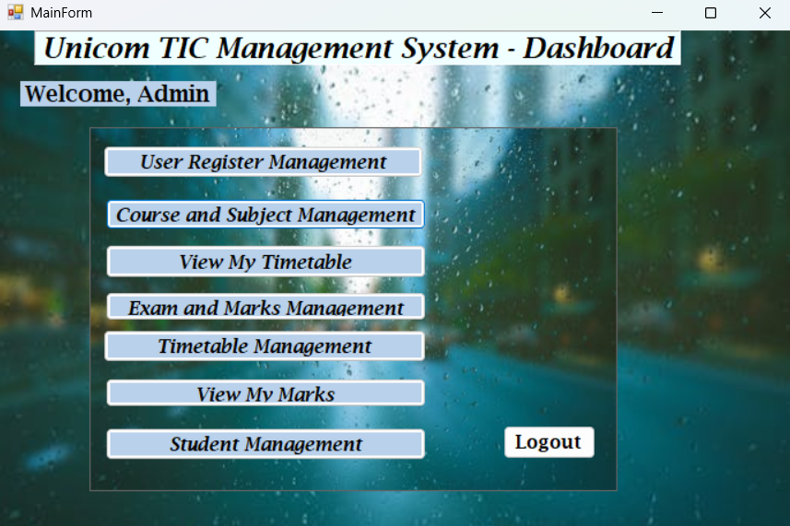

**User Registration Management (Admin Only):**

* Only the **Admin** has access to the **User Registration Management** feature.
* The Admin can **add**, **update**, and **delete** user accounts by managing their **username**, **password**, and **role**.
* The **created time** and **last updated time** of each user are displayed in the **DataGridView**.

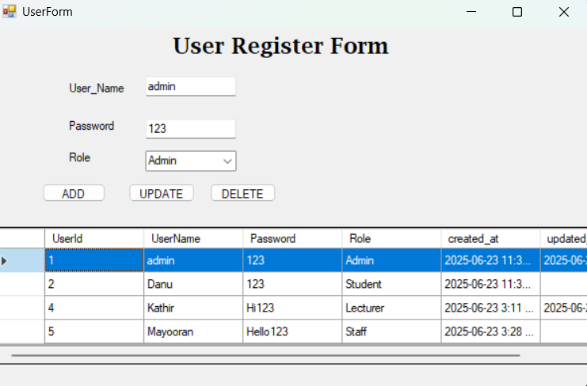

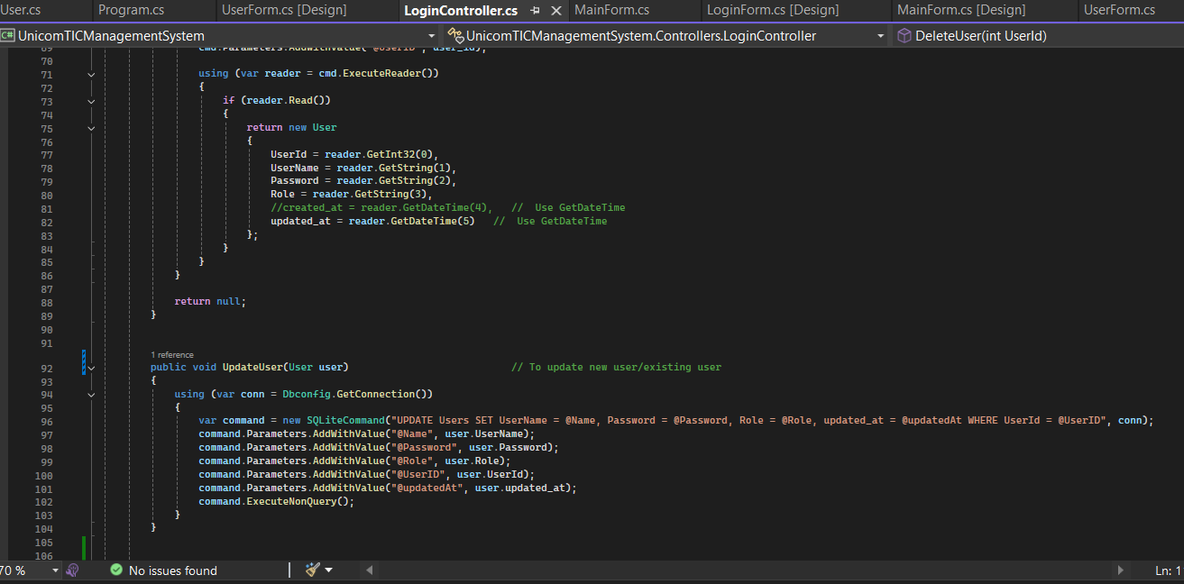

Displaying the 'Created At' and 'Updated At' timestamps is one of my best features. It allows the admin to easily track when each user was created or last modified, directly within the DataGridView after any creation or update action.